Chandni Singhal  Flat no: 2-6 Atul Plaza, Opp. Radhe Heights Near Bhondve Corner,  Akurdi, Pune-411044  csinghal101@gmail.com  +91 8237309281 | 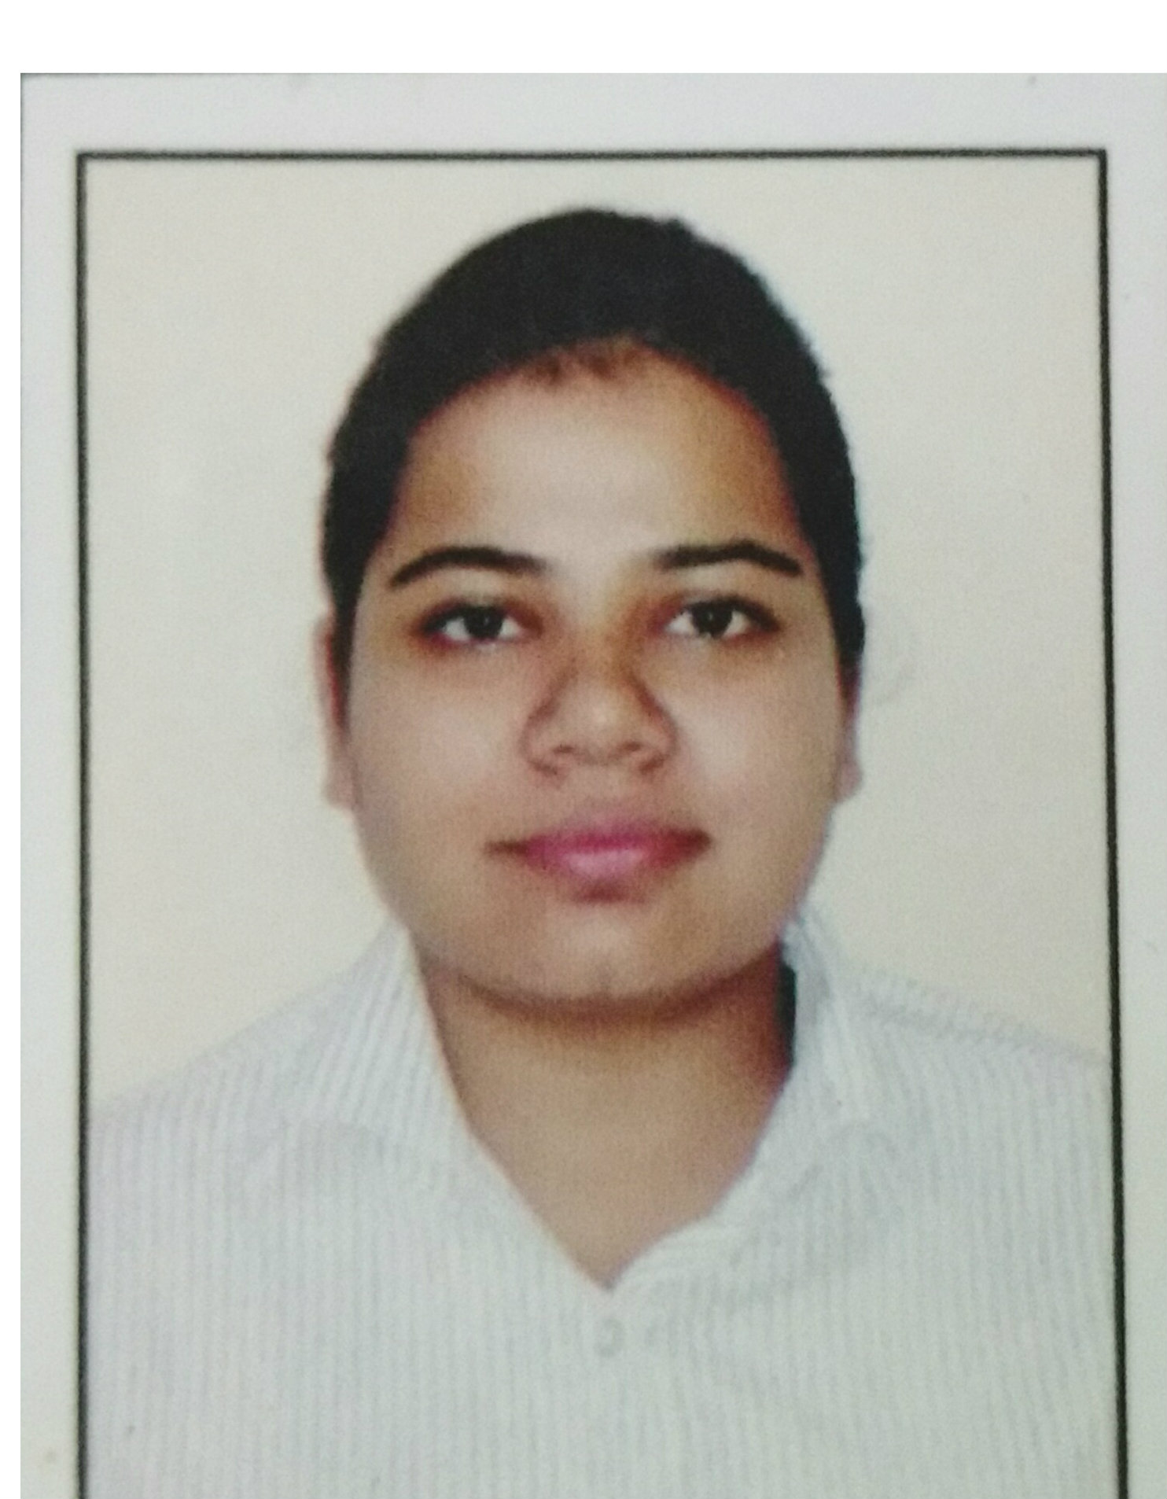
CAREER OBJECTIVE
To seek an opportunity which will allow me to grow professionally, while effectively utilizing my skills to make positive contributions to my organization.
TECHNICAL SKILLS
Programming Languages | C, C++, JAVA(core)
Database | MySQL
Web Technologies | HTML
Operating System | Windows Family, Ubuntu, Fedora

EDUCATIONAL QUALIFICATION

Engineering Aggregate: - 63%
Qualification | Institution | Board/University | % | Year
B.E | D.Y Patil College Of Engg.Akurdi | Savitribai Phule Pune University | 70% | 2015-16
T.E | D.Y Patil College Of Engg. Akurdi | Savitribai Phule Pune University | 63.53% | 2014-15
S.E | D.Y Patil College Of Engg. Akurdi | Savitribai Phule Pune University | 60% | 2013-14
F.E | D.Y Patil College Of Engg. Akurdi | Savitribai Phule Pune University | 55.14 | 2012-13
H.S.C | St.Michael’s High School | C.B.S.E | 66% | 2010-11
S.S.C | St.Joseph’s High School | C.B.S.E | 85% | 2008-09

PROJECTS
1. Name : Hotel Management
Member : 4
Duration : 3 months
Description: Using JAVA in the front end and MySQL at the back end, a basic mini project on hotel room reservation services acknowledging the customer about room availability by room type and cost, with separate login for the customer and admin. All the data about the rooms are maintained in MySQL database, connectivity between JAVA and
MySQL has been done with the help of JDBC connectivity.

2. Name : VD-KNN Query Processing (Current)
Member : 4
Duration : 1 year
Description : Using Salesforce database in the backend and Jscript/CSS in the frontend developed a location aware query processing module for enterprises needing location aware data. Location awareness is developed using a Voronoi Diagram based k-NN technique and the Google Maps API. The system is end to end encrypted using the RSA Protocol

PAPER PRESENTATION AND CONFERENCE
1. International Journal of Current Advanced Research Research (IJCAR) Vol 4, Issue 11, pp
465-469, November 2015 with ISSN: 2319-6505, ISSN: 2319 – 6475.
2. National Conference on Frontiers in Computing(NCFC, 2016) in association with
Savitribai Phule Pune university.
3. International Journal of Computer Science and Information Technologies (IJCSIT),
Vol.7(2),2016, 913-918 with ISSN:0975-9646.
4. Conducted Seminar on Full Disk Encryption (Based on IEEE Paper)
WORKSHOPS
1. Hackers Tantra Underground
2.Digital Forensic Workshop
3.Kites PC Assembly
4.</C>ODESENSES

EXTRA CURRICULAR ACTIVITIES
1. Hosted the Engineer’s Day function
2. Directed and Scripted the play SKILL’S AT 90’s for ESDL

PERSONAL DETAILS
Date of Birth : 02/25/1993
Fathers Name : Mr.Dinesh Singhal
Sex : Female
Marital Status : Single
Address : Flat No: 102 Shantivan Apartment Phase-I Opposite Apollo
Trauma Center Kankarbagh Patna-800020
Nationality : Indian
Languages : English, Hindi, Marwadi
Hobbies : Reading Novels, Listening Music, D.I.Y, Dancing

DECLARATION
I hereby declare that the above written particulars are true to the best of my knowledge and belief.
Yours Faithfully,
Chandni Singhal

